Average Test Plan

Since the code is given, most of the testing will be done using the ‘rubber-duck’ technique.

Running the given code :

Here is the output when running the original code :
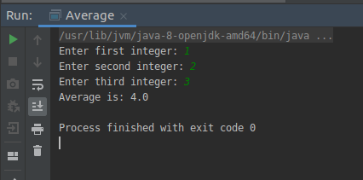

This isn’t right, the correct output should be 2.

By looking at the code line by line, a problem comes into the spotlight :

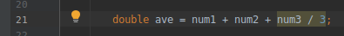

The division on this line isn’t programmed correctly, therefore the results can’t be correct.

Testing improvements :

The code runs fine after correcting said line like so :

